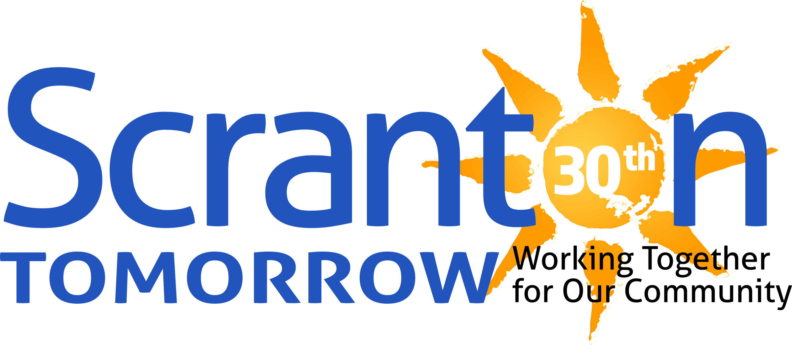

FOR IMMEDIATE RELEASE

October 5, 2023

**CONTACTS:**

**Leslie Collins Rose Randazzo Pizzuto Steve Ward,** Program Manager

*President/CEO Chairperson,* Scranton Tomorrow’s Scranton Tomorrow’s Safe, Clean,

Scranton Tomorrow Mural Arts Program Green & Design Program

[leslie@scrantontomorrow.org](mailto:leslie@scrantontomorrow.org) [rose@scrantontomorrow.org](mailto:rose@scrantontomorrow.org) [steve@scrantontomorrow.org](mailto:steve@scrantontomorrow.org)

(570) 614.6058 (570) 575.0666 (570) 877.2513

*(phone not for publication) (phone not for publication) (phone not for publication)*

It’s official: October 6, 2023, is ‘The Office Day’ in the City of Scranton

and Lackawanna County!

**(SCRANTON, PA)** – Scranton Tomorrow leaders are pleased to announce Mayor Paige G. Cognetti, City of Scranton, and Lackawanna County Commissioners Jerry Notarianni, Debi Domenick, Esq., and Chris Chermak have designated October 6, 2023, as “The Office Day” in The City of Scranton and in Lackawanna County. Representatives from both governmental bodies will present formal proclamations tomorrow night at the Dedication Ceremony for *The Office: The Story of Us* mural by Hagopian Arts at 503 Lackawanna Avenue, Downtown Scranton.

The mural is the fourth in a series of public art works developed through Scranton Tomorrow’s Mural Arts Program. The project is supported by Universal Television and Peacock, and premier sponsor Lackawanna County Visitors Bureau. The proclamations celebrate Scranton Tomorrow’s Mural Arts Program, including the completion of *The Office: The Story of Us* mural, and the contributions it makes

to the local economy by enhancing tourism, showcasing the culture and history of the community,

and enriching the quality of life for those who live and work in Scranton and Lackawanna County.

*The Office*, the hit television series set in Scranton, Pennsylvania (which aired on NBC from 2005 to 2013) has brought considerable notoriety to the city. Created by Greg Daniels, Peacock is the exclusive streaming home of the half-hour comedy *The Office*. In addition to full episodes, the platform also offers behind-the-scenes footage including bloopers, featurettes, and interviews with cast and producers. From Universal Television, a division of Universal Studio Group, the ensemble series stars Steve Carell as Michael Scott, John Krasinski as Jim Halpert, Jenna Fischer as Pam Beesly, and Rainn Wilson as Dwight Schrute.

The Dedication Ceremony opens with musical entertainment by Marko Marcinko and the SJF All Starts at 5 p.m. on Friday, October 6, at the mural site. A brief program, including proclamation presentations and a few surprise Dundie Awards, will follow at 5:30 p.m. A Meet and Greet the Artist event inside the Loft Wine Bar & Events, 503 Lackawanna Avenue, will be held from 6 to 7 p.m. The Meet is Greet is sponsored by Lackawanna County Arts & Culture Department and The Loft Wine Bar & Events. The festivities are open to the public and guests are encouraged to enjoy First Friday throughout Downtown Business District until 9 p.m. To learn more, visit [*scrantontomorrow.org*](https://www.scrantontomorrow.org/) and follow Scranton Tomorrow on social media. To download a First Friday map, visit [*firstfridayscranton.com*](https://firstfridayscranton.com/).

###