media kit

September 2023

## The Office: The Story of Us

by Hagopian Arts

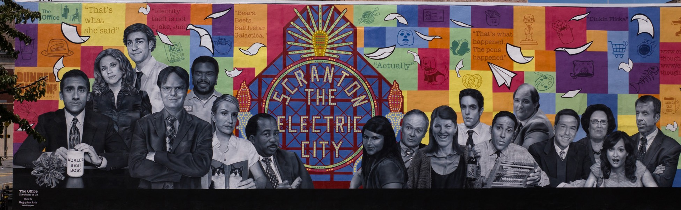

A project of: With support from: Premier sponsor:

# the project leaders



**Leslie Memolo Collins** *President & CEO* [*leslie@scrantontomorrow.org*](mailto:leslie@scrantontomorrow.org)

**Elizabeth Baldi**

*Business Development Director* [*lizbaldi@scrantontomorrow.org*](mailto:lizbaldi@scrantontomorrow.org)

**Steve Ward**

*Project Manager of Safe, Clean, Green & Design Program* [*steve@scrantontomorrow.org*](mailto:steve@scrantontomorrow.org)

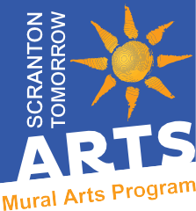

**Rose Randazzo-Pizutto** *Chairperson, Scranton Tomorrow Mural Arts Program* [*rose@scrantontomorrow.org*](mailto:rose@scrantontomorrow.org)

### Scranton Tomorrow

**Scranton Tomorrow** is a 501 c(3) nonprofit, nonpartisan community and economic development organization working to establish Scranton as the premier urban center of northeastern Pennsylvania.

Its headquarters are located at 307 Linden Street in

historic Downtown Scranton, Pennsylvania.

Scranton Tomorrow is a volunteer-based organization whose members are as diverse as the greater Scranton community. Volunteers and supporters include business leaders, public officials, entrepreneurs, property owners, developers, educators, artists and community partners - all united in a love for the City of Scranton and a commitment to reach its greatest potential.

[**Learn More:** scrantontomorrow.org](https://www.scrantontomorrow.org/)

### Mural Arts Program

Scranton Tomorrow launched its **Mural Arts Program** in 2021. Designed to transform the Downtown Scranton landscape, and connect communities, murals reflect the city’s history and qualities that make Scranton unique.

QR codes are posted at each site, allowing visitors to use their smartphones to embark on brief, self-guided tours.

[**Learn More:** scrantontomorrow.org/muralart](https://www.scrantontomorrow.org/muralart)

# the supporters

*Partners*

2



*Premier Sponsor*

***The Office: The Story of Us*** mural by Hagopian Arts is a project of Scranton Tomorrow with support from Universal Television and Peacock, and premier sponsor Lackawanna County Visitors Bureau.

Additional community sponsors include Community Bank, N.A., Cooper’s Seafood House, and The Greater Scranton Chamber of Commerce.

**Media Inquiries:**

Julie D. Imel Communications Scranton, Pennsylvania

[juliedimelwriter@gmail.com](mailto:juliedimelwriter@gmail.com)

(570) 335.7749

**On the Cover:**

*The Office: The Story of Us mural by Hagopian Arts, a project of Scranton Tomorrow with support from Universal Television and Peacock, and premier sponsor Lackawanna County Visitors Bureau. Photo by Justin Bare, XXII Media, courtesy of Hagopian Arts. August 2023.*

# the backstory

he story behind ***The Office: The Story of Us***

the show

*The Office*, the hit television series set in Scranton, Pennsylvania (which aired on NBC from 2005 to 2013) has brought considerable notoriety to the city.

Created by Greg Daniels, Peacock is the exclusive streaming home of the half-hour comedy *The Office*. In addition to full episodes, the platform also offers behind- the-scenes footage including bloopers, featurettes, and interviews with cast and producers. From Universal Television, a division of Universal Studio Group, the ensemble series stars Steve Carell as Michael Scott, John Krasinski as Jim Halpert, Jenna Fischer as Pam Beesly, and Rainn Wilson as Dwight Schrute.

T

mural dates back to 2020. That was the year Rose Randazzo-Pizzuto, a volunteer and longtime advocate of the arts, approached Scranton Tomorrow leaders about creating a formal Mural Arts Program. A mural paying tribute to *The Office*, the hit NBC comedy set in Scranton, Pennsylvania (2005 to 2013) was among the top items on her wish list of concepts.

Scranton Tomorrow is a non-profit economic development organization in Scranton, Pennsylvania, that has been devoted to enhancing the quality of life for those who live and work in Scranton for more than 30 years.

With experience developing murals through a similar program in nearby Pittston, Pennsylvania, Randazzo-Pizzuto had a sense of what kind of projects would resonate well with Scrantonians and visitors to the Electric City. “This was one of the first public art projects I wanted to do in Scranton. There is nothing better to bring people into our downtown than public art,” Randazzo-Pizzuto said. “I knew a

mural with characters from *The Office* would enhance tourism. The show was already one of the top tourist attractions in the city, and if we married that with a downtown mural, we would have a winner.”

Scranton Tomorrow’s Mural Arts Program formally launched in 2021. To date, four murals have been installed in Downtown Scranton through the program, including *The Office: The Story of Us* by Hagopian Arts.

3

“We are so proud of our Mural Arts Program,”

said Leslie Collins, president and CEO of Scranton Tomorrow. “The program aligns beautifully with our economic development priorities as we work to position Scranton as the economic center of northeastern Pennsylvania,” Collins said. “Public art enhances the quality of life for everyone, and we are grateful for the support we’ve received from business leaders, community partners, and artists as the program continues to grow.”

In 2021, Scranton Tomorrow leaders began fundraising and working on the logistics of the project, including selecting an artist. They commissioned Kala Hagopian, lead artist and founder of Hagopian Arts, Philadelphia, specializing in fine art murals.

In fall 2022, artists began painting the mural

in-studio on sections of parachute cloth, following the process required by the Mural Arts Program to ensure the artwork’s longevity. In August 2023, the mural was transported to Scranton and installed at 503 Lackawanna Avenue to the delight of super fans from across the country.

Featuring realistic black-and-white portraits of

17 cast members, famous quotes from the show, local landmarks referenced in the series, and colorful geometric shapes, the finished piece is 86 feet wide by 27 feet tall.

***The Office: The Story of Us*** *mural by Hagopian Arts is a project of Scranton Tomorrow with support from Universal Television and Peacock, and premier sponsor Lackawanna County Visitors Bureau. Additional community sponsors include Community Bank, N.A., Cooper’s Seafood House, and The Greater Scranton Chamber of Commerce.*

# the process

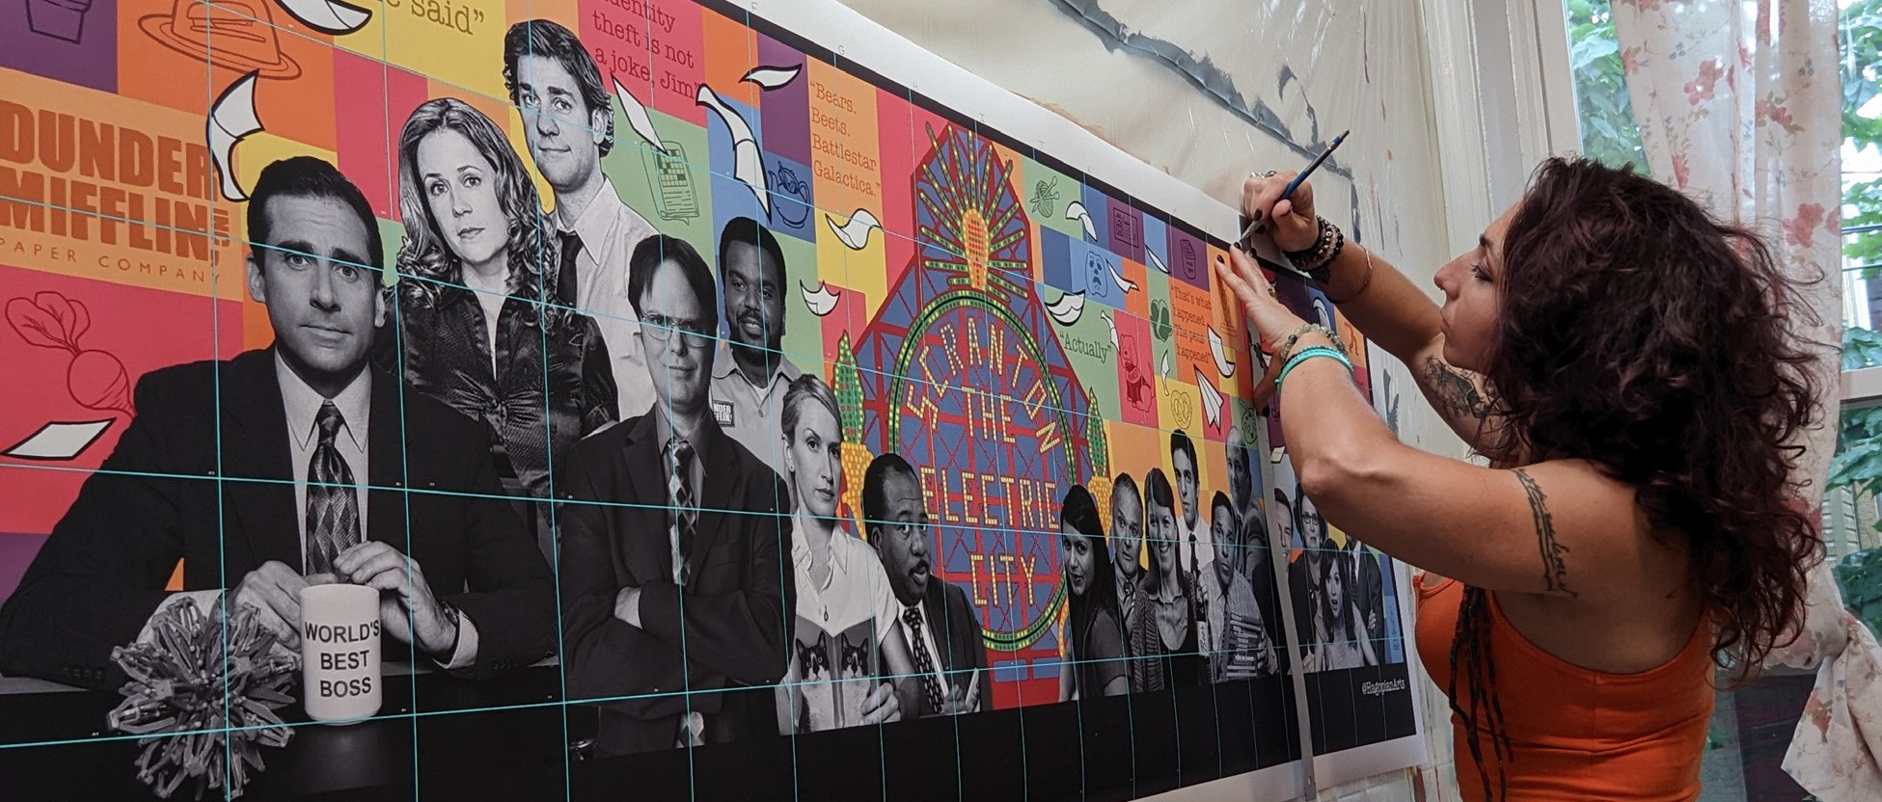

[Detail of fine arts muralist **Kala Hagopian**, founder of Hagopian Arts, as she refines the design of *The Office: The Story of Us* mural, a project of Scranton Tomorrow with support from Universal Television and Peacock, and premier sponsor Lackawanna County Visitors Bureau.](https://photos.app.goo.gl/rmDNMPNDot2mNXAH6)

[The mural features realistic black-and-white portraits of 17 cast members, famous quotes from the show, local landmarks referenced in the series, and colorful geometric shapes. Located at 503 Lackawanna Avenue, Scranton, Pennsylvania, the mural is 86’ wide by 27’ tall.](https://photos.app.goo.gl/rmDNMPNDot2mNXAH6)

[*Photo: Hagopian Arts. October 2022.*](https://photos.app.goo.gl/rmDNMPNDot2mNXAH6)

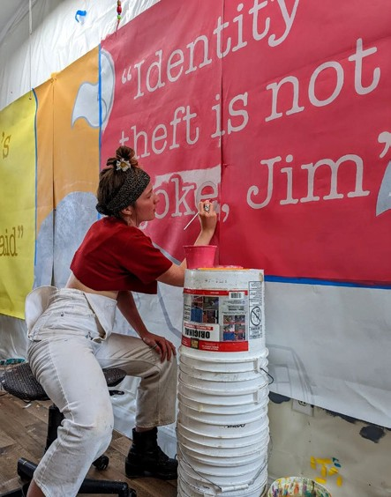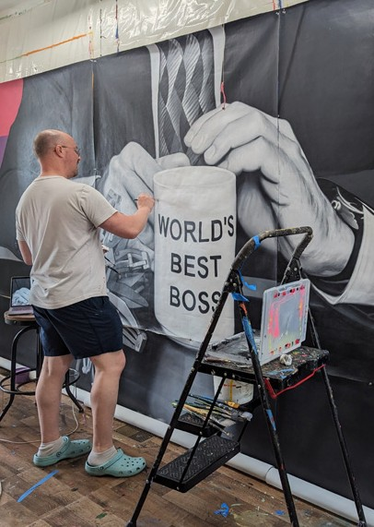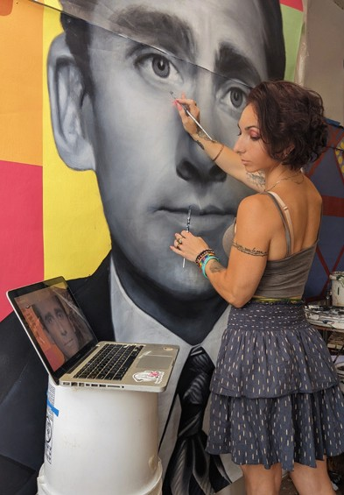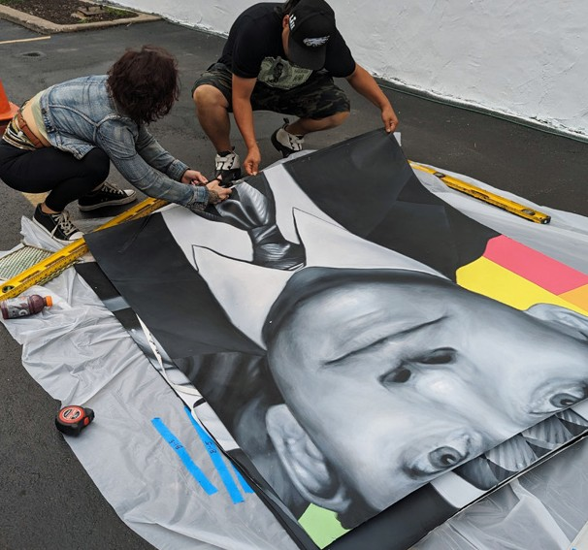

[**Noel Yheaulon** brings those famous one-liners to life!](https://photos.app.goo.gl/rmDNMPNDot2mNXAH6)

[*Photo: Hagopian Arts.*](https://photos.app.goo.gl/rmDNMPNDot2mNXAH6)

[November 2022.](https://photos.app.goo.gl/rmDNMPNDot2mNXAH6)

[**Garrette Cook** paints the famous “World’s Best Boss” mug. *Photo: Hagopian Arts. July 2023.*](https://photos.app.goo.gl/rmDNMPNDot2mNXAH6)

[**Kala Hagopian** adds intricate details to the portrait of Dunder Mifflin Regional Manager Michael Scott (Steve Carell). *Photo: Hagopian Arts. July 2023.*](https://photos.app.goo.gl/rmDNMPNDot2mNXAH6)

[After in-studio painting was finished, the Hagopian Arts team transported the mural in sections from Philadelphia to Scranton for installation at 503 Lackawanna Avenue.](https://photos.app.goo.gl/rmDNMPNDot2mNXAH6)

[*Photo: Hagopian Arts. August 2023.*](https://photos.app.goo.gl/rmDNMPNDot2mNXAH6)

[**Click here to download photos and captions**](https://photos.app.goo.gl/rmDNMPNDot2mNXAH6)

esign, production and

D

installation of *The Office: The Story of Us* was a year-long process for Hagopian Arts. After the design was approved, Kala

Hagopian, lead artist and founder of Hagopian Arts, and her team painted the mural in-studio in Philadelphia on sections of parachute cloth.

It was then transported to Scranton for installation and final touch-ups. Following the protocols required by Scranton Tomorrow’s Mural Arts Program to ensure the artwork’s longevity, the mural was affixed

to the wall at 503 Lackawanna Avenue using a powerful adhesive gel that dries clear and takes on the texture of the surface on which is it is placed.

Hagopian added finishing touches to the piece and treated it with a UV protectant sealer. “This process makes it possible to paint all year around in my studio and allows me to capture all of the details signature to my style,” Hagopian said. “Using this method also facilitates easy and safe community engagement.”



4

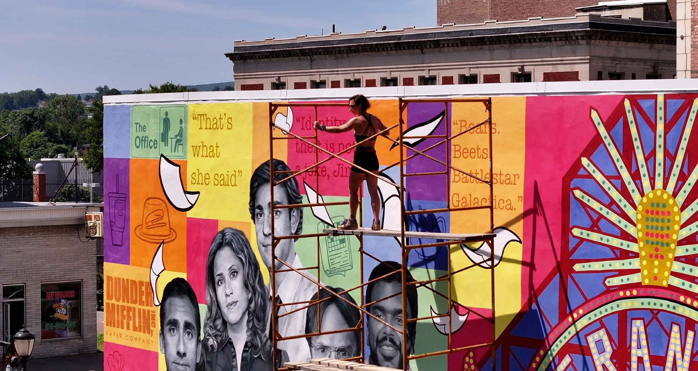

[On top of the Electric City! **Kala Hagopian** applies finishing touches to the 86’ wide by 27’ tall mural titled *The Office: The Story of Us*, a project of Scranton Tomorrow with support from Universal Television and Peacock, and premier sponsor Lackawanna County Visitors Bureau. *Photo by Justin Bare, XXII Media, courtesy of Hagopian Arts. August 2023.*](https://photos.app.goo.gl/rmDNMPNDot2mNXAH6)

### Hagopian Arts

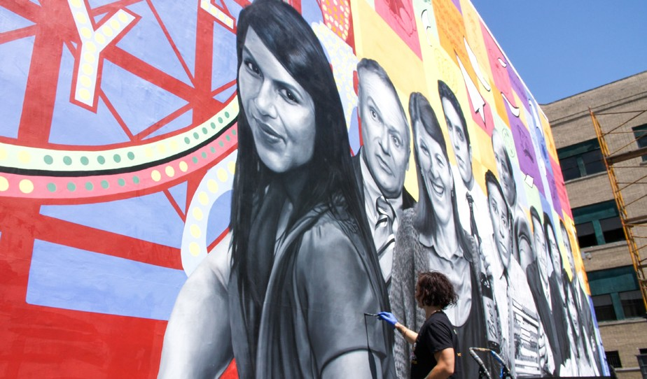

Founded by **Kala Hagopian**, Hagopian Arts is an independent, female-owned and operated public art initiative in West Philadelphia. Hagopian holds

a Certificate from the Pennsylvania Academy of the Fine Arts. A working artist in Philadelphia since 2005, she has been painting murals since 2012. Hagopian Arts produces fine art murals, specializing in realism

interspersed with bright patterns and atmosphere.

[**Learn More:** hagopianarts.com](https://www.hagopianarts.com/)

[**Kala Hagopian** adds a few final brush strokes to the portrait of Kelly Kapoor (Mindy Kaling). *Photo by Cinthya Vong, XXII Media, courtesy of Hagopian Arts. August 2023.*](https://photos.app.goo.gl/rmDNMPNDot2mNXAH6)

5

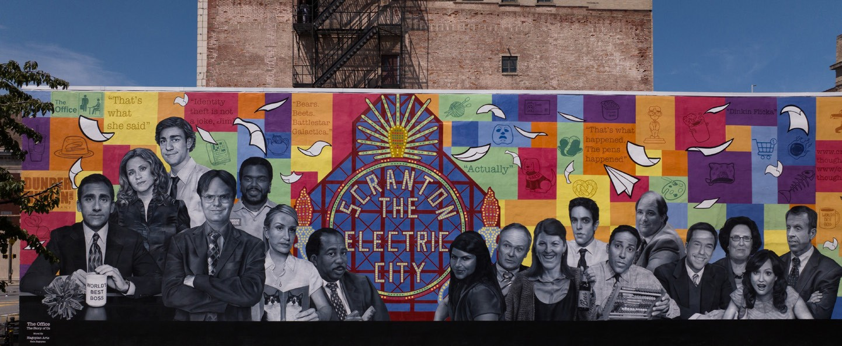

[*The Office: The Story of Us* mural by Hagopian Arts is a project of Scranton Tomorrow with support from Universal Television and Peacock, and premier sponsor Lackawanna County Visitors Bureau. The mural at 503 Lackawanna Avenue, Scranton, Pennsylvania, was completed in August 2023. *Photo by Justin Bare, XXII Media, courtesy of Hagopian Arts. August 2023.*](https://photos.app.goo.gl/rmDNMPNDot2mNXAH6)

Contributing artists

Helen Harvey Noel Yheaulon Garrette Cook Elizabeth Ramos Ash Ryan

Prince De Leon Shakeh Hagopian Tegan Bellitta Jasmine Kelly Luz Jubilee Nicholas D’Auria Jillian Kelly

John Zerbe Malachi Floyd

# the office self-guided tour

*Developed by Lackawanna County Visitors Bureau*

[n](https://www.visitnepa.org/things-to-do/self-guided-tours/the-office/)

[d,](https://www.visitnepa.org/things-to-do/self-guided-tours/the-office/)

[**der ned**](https://www.visitnepa.org/things-to-do/self-guided-tours/the-office/)

ans of *The Office* regularly enjoy self-guided tours developed by the **Lackawanna County**

[**MONROE AVE**](https://www.visitnepa.org/things-to-do/self-guided-tours/the-office/)

[**HITCHCOCK CT**](https://www.visitnepa.org/things-to-do/self-guided-tours/the-office/)

[**COSTELLO CT**](https://www.visitnepa.org/things-to-do/self-guided-tours/the-office/)

[**MYRTLE ST**](https://www.visitnepa.org/things-to-do/self-guided-tours/the-office/)

[**E GIBSON ST**](https://www.visitnepa.org/things-to-do/self-guided-tours/the-office/)

[**PINE ST**](https://www.visitnepa.org/things-to-do/self-guided-tours/the-office/)

[**OLIVE ST OLIVE ST**](https://www.visitnepa.org/things-to-do/self-guided-tours/the-office/)

[**VINE ST**](https://www.visitnepa.org/things-to-do/self-guided-tours/the-office/)

**LINDEN ST**

[**QUINCY AVE**](https://www.visitnepa.org/things-to-do/self-guided-tours/the-office/)

[**CLAY AVE**](https://www.visitnepa.org/things-to-do/self-guided-tours/the-office/)

[**INSTERST**81**ATE**](https://www.visitnepa.org/things-to-do/self-guided-tours/the-office/)

[**ural**](https://www.visitnepa.org/things-to-do/self-guided-tours/the-office/)

[n Ave](https://www.visitnepa.org/things-to-do/self-guided-tours/the-office/)

[*1* Tag](https://www.visitnepa.org/things-to-do/self-guided-tours/the-office/)

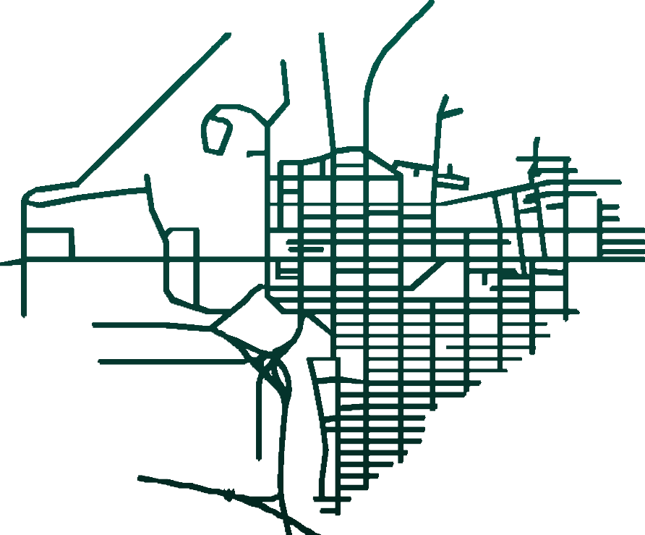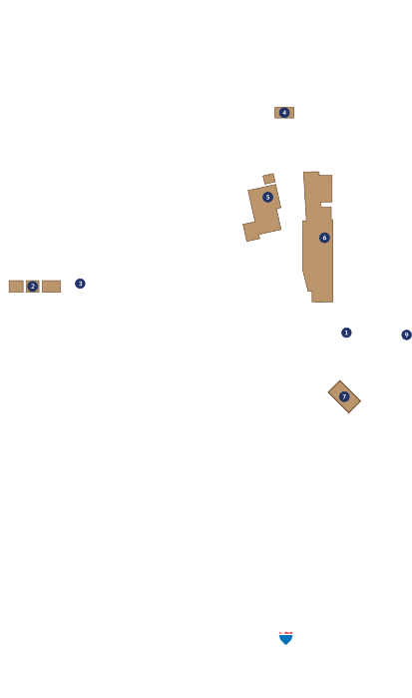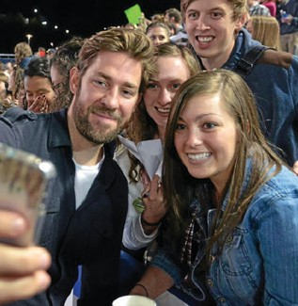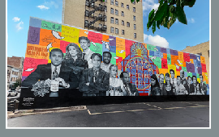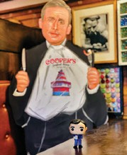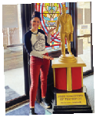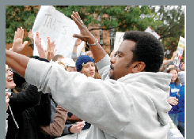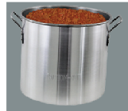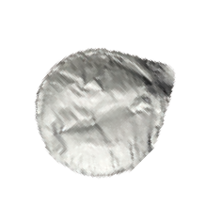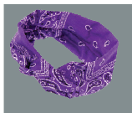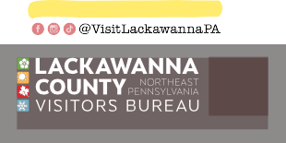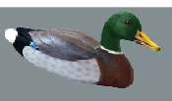

[**Welcome to Scranton, the home and mecca for fans of NBC’s hit TV show, *The Office!* Experience the world of Dun**](https://www.visitnepa.org/things-to-do/self-guided-tours/the-office/)

[**Mifflin firsthand and delve into Scranton’s most renow fictional office setting. Visit real-life locations that were highlighted and celebrated in the show!**](https://www.visitnepa.org/things-to-do/self-guided-tours/the-office/)

[NOT ON THE MAP.](https://www.visitnepa.org/things-to-do/self-guided-tours/the-office/)

[**Lackawanna Coal Mine Tour** 1 Bald Mountain Rd, Scranton *Season 1, Episode 3*](https://www.visitnepa.org/things-to-do/self-guided-tours/the-office/)

[**Anthracite Heritage Museum** 22 Bald Mountain Rd, Scranton *Season 1, Episode 3*](https://www.visitnepa.org/things-to-do/self-guided-tours/the-office/)

[*Season 3, Episode 8*](https://www.visitnepa.org/things-to-do/self-guided-tours/the-office/)

[**Houdini Museum**](https://www.visitnepa.org/things-to-do/self-guided-tours/the-office/)

[1433 N Main Ave, Scranto](https://www.visitnepa.org/things-to-do/self-guided-tours/the-office/)

[*Season 8, Episode 19*](https://www.visitnepa.org/things-to-do/self-guided-tours/the-office/)

[ON THE SCRANTON MAP.](https://www.visitnepa.org/things-to-do/self-guided-tours/the-office/)

1. [***The Office:***](https://www.visitnepa.org/things-to-do/self-guided-tours/the-office/)

[**The Story of Us Mural**](https://www.visitnepa.org/things-to-do/self-guided-tours/the-office/)

[503 Lackawanna Ave](https://www.visitnepa.org/things-to-do/self-guided-tours/the-office/)

1. [**Alfredo’s Pizza Café** 1040 S Washington Ave *Season 4, Episodes 1 & 3*](https://www.visitnepa.org/things-to-do/self-guided-tours/the-office/)

[*Season 6, Episode 15*](https://www.visitnepa.org/things-to-do/self-guided-tours/the-office/)

1. [**Poor Richard’s Pub**](https://www.visitnepa.org/things-to-do/self-guided-tours/the-office/)

[125 Beech St](https://www.visitnepa.org/things-to-do/self-guided-tours/the-office/)

[*Season 2, Episodes 1, 5 &*](https://www.visitnepa.org/things-to-do/self-guided-tours/the-office/)

[*Season 3, Episodes 7 & 17*](https://www.visitnepa.org/things-to-do/self-guided-tours/the-office/)

[*Season 4, Episode 5*](https://www.visitnepa.org/things-to-do/self-guided-tours/the-office/)

[*Season 6, Episode 19*](https://www.visitnepa.org/things-to-do/self-guided-tours/the-office/)

[**PNC Field**](https://www.visitnepa.org/things-to-do/self-guided-tours/the-office/)

[235 Montag](https://www.visitnepa.org/things-to-do/self-guided-tours/the-office/)

[e Mountain R](https://www.visitnepa.org/things-to-do/self-guided-tours/the-office/)

[**MIFFLIN AVE**](https://www.visitnepa.org/things-to-do/self-guided-tours/the-office/)

[Moosic](https://www.visitnepa.org/things-to-do/self-guided-tours/the-office/)

[**HALLS**](https://www.visitnepa.org/things-to-do/self-guided-tours/the-office/)

[**FRANKLIN AVE**](https://www.visitnepa.org/things-to-do/self-guided-tours/the-office/)

[*Site of Wrap Party: Farewell Celebration*](https://www.visitnepa.org/things-to-do/self-guided-tours/the-office/)

[**The Pavilion at Montage Mountain** 1000 Montage Mountain Rd, Scranton *Season 2, Episode 20*](https://www.visitnepa.org/things-to-do/self-guided-tours/the-office/)

[*Season 9, Episodes 6 & 22*](https://www.visitnepa.org/things-to-do/self-guided-tours/the-office/)

1. [**Electric City Trolley Station & Museum**](https://www.visitnepa.org/things-to-do/self-guided-tours/the-office/)

[300 Cliff St](https://www.visitnepa.org/things-to-do/self-guided-tours/the-office/)

[*‘Electric City’ Nickname Origin*](https://www.visitnepa.org/things-to-do/self-guided-tours/the-office/)

1. [**Steamtown National Historic Site**](https://www.visitnepa.org/things-to-do/self-guided-tours/the-office/)

[350 Cliff St](https://www.visitnepa.org/things-to-do/self-guided-tours/the-office/)

[*Season 4, Episode 4*](https://www.visitnepa.org/things-to-do/self-guided-tours/the-office/)

1. [**The Marketplace at Steamtown (‘Scranton Welcomes You’ Sign, Auntie Anne’s, Boscov’s)**](https://www.visitnepa.org/things-to-do/self-guided-tours/the-office/)

[300 Lackawanna Ave](https://www.visitnepa.org/things-to-do/self-guided-tours/the-office/)

[*Season 2, Episode 20*](https://www.visitnepa.org/things-to-do/self-guided-tours/the-office/)

[*Season 3, Episode 21*](https://www.visitnepa.org/things-to-do/self-guided-tours/the-office/)

[*Season 5, Episode 26*](https://www.visitnepa.org/things-to-do/self-guided-tours/the-office/)

1. [**Radisson Lackawanna Station Hotel Scranton** 700 Lackawanna Ave](https://www.visitnepa.org/things-to-do/self-guided-tours/the-office/)

[*Season 2, Episodes 7, 17 & 22*](https://www.visitnepa.org/things-to-do/self-guided-tours/the-office/)

[*Season 5, Episode 23*](https://www.visitnepa.org/things-to-do/self-guided-tours/the-office/)

1. [**The University of Scranton**](https://www.visitnepa.org/things-to-do/self-guided-tours/the-office/)

[900 Mulberry St](https://www.visitnepa.org/things-to-do/self-guided-tours/the-office/)

[*Season 1, Episode 5*](https://www.visitnepa.org/things-to-do/self-guided-tours/the-office/)

1. [**Lackawanna County Courthouse (Dwight is a Volunteer Sheriff’s Deputy)** 200 N Washington Ave *Season 2, Episode 20*](https://www.visitnepa.org/things-to-do/self-guided-tours/the-office/)

[**10 Electric City Sign**](https://www.visitnepa.org/things-to-do/self-guided-tours/the-office/)

[507 Linden St](https://www.visitnepa.org/things-to-do/self-guided-tours/the-office/)

[*Season 3, Episode 8*](https://www.visitnepa.org/things-to-do/self-guided-tours/the-office/)

[**11 Backyard Ale House**](https://www.visitnepa.org/things-to-do/self-guided-tours/the-office/)

[523 Linden St *Site of Wrap Party: The After Party*](https://www.visitnepa.org/things-to-do/self-guided-tours/the-office/)

[**12 The Bog**](https://www.visitnepa.org/things-to-do/self-guided-tours/the-office/)

[341 Adams Ave](https://www.visitnepa.org/things-to-do/self-guided-tours/the-office/)

[*Season 5, Episode 11*](https://www.visitnepa.org/things-to-do/self-guided-tours/the-office/)

[**13 Dundie Award** Scranton City Hall 340 N Washington Ave *Opening Credits Season 2, Episode 1*](https://www.visitnepa.org/things-to-do/self-guided-tours/the-office/)

[*Season 7, Episode 20*](https://www.visitnepa.org/things-to-do/self-guided-tours/the-office/)

[**14 Scranton Cultural Center at Masonic Temple**](https://www.visitnepa.org/things-to-do/self-guided-tours/the-office/)

[420 N Washington Ave](https://www.visitnepa.org/things-to-do/self-guided-tours/the-office/)

[*Season 9, Episode 23*](https://www.visitnepa.org/things-to-do/self-guided-tours/the-office/)

1. [**Pennsylvania Paper & Supply Co.** 215 Vine St *Opening Credits*](https://www.visitnepa.org/things-to-do/self-guided-tours/the-office/)
2. [**Cooper’s Seafood House** 701 N Washington Ave *Season 3, Episodes 7 & 8*](https://www.visitnepa.org/things-to-do/self-guided-tours/the-office/)

[*Season 4, Episode 3*](https://www.visitnepa.org/things-to-do/self-guided-tours/the-office/)

[*Season 5, Episodes 2 & 11*](https://www.visitnepa.org/things-to-do/self-guided-tours/the-office/)

[*Season 6, Episode 14*](https://www.visitnepa.org/things-to-do/self-guided-tours/the-office/)

1. [**Dwight Schrute M**](https://www.visitnepa.org/things-to-do/self-guided-tours/the-office/)

[On&On](https://www.visitnepa.org/things-to-do/self-guided-tours/the-office/)

[1138 Capouse Ave](https://www.visitnepa.org/things-to-do/self-guided-tours/the-office/)

1. [**Andy Gavin’s Eatery & Pub** 1392 N Washingto](https://www.visitnepa.org/things-to-do/self-guided-tours/the-office/)

[*Season 5, Episode 1*](https://www.visitnepa.org/things-to-do/self-guided-tours/the-office/)

[**Kelly’s Pub & Eatery** 1802 Cedar Ave, Scranton *Season 5, Episode 11*](https://www.visitnepa.org/things-to-do/self-guided-tours/the-office/)

[**Lake Scranton**](https://www.visitnepa.org/things-to-do/self-guided-tours/the-office/)

[Route 307, Scranto](https://www.visitnepa.org/things-to-do/self-guided-tours/the-office/)

[*Season 3, Episode 22*](https://www.visitnepa.org/things-to-do/self-guided-tours/the-office/)

[*Season 4, Episode 2*](https://www.visitnepa.org/things-to-do/self-guided-tours/the-office/)

[**Glider Diner**](https://www.visitnepa.org/things-to-do/self-guided-tours/the-office/)

[890 Providence Rd, Scranton](https://www.visitnepa.org/things-to-do/self-guided-tours/the-office/)

[*Season 4, Episode 14*](https://www.visitnepa.org/things-to-do/self-guided-tours/the-office/)

[**Gertrude Hawk Chocolates** 909 Keystone Industrial Park, Throop](https://www.visitnepa.org/things-to-do/self-guided-tours/the-office/)

[*Season 2, Episode 22*](https://www.visitnepa.org/things-to-do/self-guided-tours/the-office/)

[*Season 4, Episode 2*](https://www.visitnepa.org/things-to-do/self-guided-tours/the-office/)

[your pics & vids!](https://www.visitnepa.org/things-to-do/self-guided-tours/the-office/)

[**City of Carbondale**](https://www.visitnepa.org/things-to-do/self-guided-tours/the-office/)

[*Season 2, Episode 12*](https://www.visitnepa.org/things-to-do/self-guided-tours/the-office/)

[*Season 3, Episode 20*](https://www.visitnepa.org/things-to-do/self-guided-tours/the-office/)

[*Season 7, Episode 21*](https://www.visitnepa.org/things-to-do/self-guided-tours/the-office/)

[**Lake Wallenpaupack**](https://www.visitnepa.org/things-to-do/self-guided-tours/the-office/)

[*Season 2, Episode 11*](https://www.visitnepa.org/things-to-do/self-guided-tours/the-office/)

[*Season 3, Episode 12*](https://www.visitnepa.org/things-to-do/self-guided-tours/the-office/)

[Scan for more information about the locations on the tour!](https://www.visitnepa.org/things-to-do/self-guided-tours/the-office/)

F

**Visitors Bureau**. The map features dozens of restaurants, businesses, and landmarks referenced in the show. While visiting Scranton, fans can plan their itinerary and enjoy the tour at their own pace.

# the impact

* ***The Office***, the hit television series set in Scranton, Pennsylvania (which aired on NBC from 2005 to 2013) has brought considerable notoriety to the city.
* **Eight out of the 20** most frequent Google searches involving Lackawanna County include *The Office*.

#### Scan to download the map and learn more about the locations!

Follow the map online, download it, or pick up a brochure at the Lackawanna County Visitors Bureau, 135 Jefferson Ave, Scranton, PA, 18503.

[**Learn more:** *visitnepa.org/the-office*](https://www.visitnepa.org/things-to-do/self-guided-tours/the-office/)

* [***The Office Self-Guided Tour*** on the Visitors Bureau’s website at *visitnepa.org/ the-office* has been the most frequented page on their site for the past five years. In 2022, **70,000 people** visited the page.](https://www.visitnepa.org/things-to-do/self-guided-tours/the-office/)
* **Lackawanna County Visitors Bureau** has distributed tens of thousands of brochures featuring the popular map of Dunder Mifflin destinations.

*Source: Lackawanna County Visitors Bureau*

[**RAYMOND CT**](https://www.visitnepa.org/things-to-do/self-guided-tours/the-office/)

[**PENN AVE**](https://www.visitnepa.org/things-to-do/self-guided-tours/the-office/)

[**OAKFORD CT**](https://www.visitnepa.org/things-to-do/self-guided-tours/the-office/)

[**WYOMING AVE**](https://www.visitnepa.org/things-to-do/self-guided-tours/the-office/)

[**FOREST CT DUPONT CT**](https://www.visitnepa.org/things-to-do/self-guided-tours/the-office/)

[**N WASHINGTON AVE**](https://www.visitnepa.org/things-to-do/self-guided-tours/the-office/)

[**DIX CT LEE CT**](https://www.visitnepa.org/things-to-do/self-guided-tours/the-office/)

[**ADAMS AVE**](https://www.visitnepa.org/things-to-do/self-guided-tours/the-office/)

[**KRESSLER CT**](https://www.visitnepa.org/things-to-do/self-guided-tours/the-office/)

[**JEFFERSON AVE**](https://www.visitnepa.org/things-to-do/self-guided-tours/the-office/)

[**MOIR CT**](https://www.visitnepa.org/things-to-do/self-guided-tours/the-office/)

[**MADISON AVE**](https://www.visitnepa.org/things-to-do/self-guided-tours/the-office/)

[**DIX CT**](https://www.visitnepa.org/things-to-do/self-guided-tours/the-office/)

[**MCKENNA CT**](https://www.visitnepa.org/things-to-do/self-guided-tours/the-office/)

[**MONROE AVE**](https://www.visitnepa.org/things-to-do/self-guided-tours/the-office/)

**Y ST MULBERRY ST**

**LINDEN ST**

**SPRUCE ST SPRUCE ST**

**CENTER ST**

**LACKAWANNA AVE LACKAWA**

[**S WASHINGTON AVE S WASHINGTON AVE**](https://www.visitnepa.org/things-to-do/self-guided-tours/the-office/)

**RIVER ST**

[**ASH ST**](https://www.visitnepa.org/things-to-do/self-guided-tours/the-office/)

[**S WYOMING AVE**](https://www.visitnepa.org/things-to-do/self-guided-tours/the-office/)

[n](https://www.visitnepa.org/things-to-do/self-guided-tours/the-office/)

[**TEAD CT**](https://www.visitnepa.org/things-to-do/self-guided-tours/the-office/)

**MULBERR**

[*10*](https://www.visitnepa.org/things-to-do/self-guided-tours/the-office/)



**PAGE PL**

6

# the fun facts

the links to learn more

[**Why is Scranton called the Electric City?**](https://www.scranton.edu/about/location.shtml)

[scranton.edu/about/location.shtml](https://www.scranton.edu/about/location.shtml)

[**The Electric City sign**](https://www.hmdb.org/m.asp?m=101477)

[hmdb.org/m.asp?m=101477](https://www.hmdb.org/m.asp?m=101477)

[**Historic architecture in Downtown Scranton**](https://www.scrantontomorrow.org/design)

[scrantontomorrow.org/design](https://www.scrantontomorrow.org/design)

[**Things to do in Scranton & Lackawanna County**](https://www.visitnepa.org/)

[visitnepa.org](https://www.visitnepa.org/)

7

ere are a few facts about the relationship between the real City of Scranton and the fictional story of a beloved paper company set in

H

Scranton. Each item is worthy of a Sticky Quip!

* Scranton’s historic buildings and iconic landmarks appear in *The Office*, including the **Pennsylvania Paper and Supply Co.** building in the show’s famous opening, and

the **Electric City sign** in *Season 3, Episode 8*.

* The show references numerous **Scranton businesses,** including Alfredo’s Pizza Cafe (not to be confused with Pizza by Alfredo’s), Andy Gavin’s Eatery & Pub, The Bog, Cooper’s Seafood House, The Glider

Diner, Kelly’s Pub & Eatery, The Marketplace at Steamtown, Poor Richard’s Pub, and the Radisson Lackawanna Station Hotel.

* Scranton’s rich **cultural history** is reflected

in the series with mentions of the Anthracite Heritage Museum, Electric City Trolley Station & Museum, the Houdini Museum, Lackawanna Coal Mine Tour, Scranton Cultural Center at the Masonic Temple, and Steamtown National Historic Site.

* **Lake Scranton** is the setting of the *Beach Games* episode in *Season 3, Episode 22*, and it is also the natural body of water into which Michael Scott plunged his rental car while following faulty GPS directions in *Season 4, Episode 2.*
* The **Scranton Welcomes You** sign formerly posted at the gateway to Downtown Scranton on The President Joseph R. Biden, Jr. Expressway has been preserved and stored in honor of its appearance in the show’s famous opening.
* 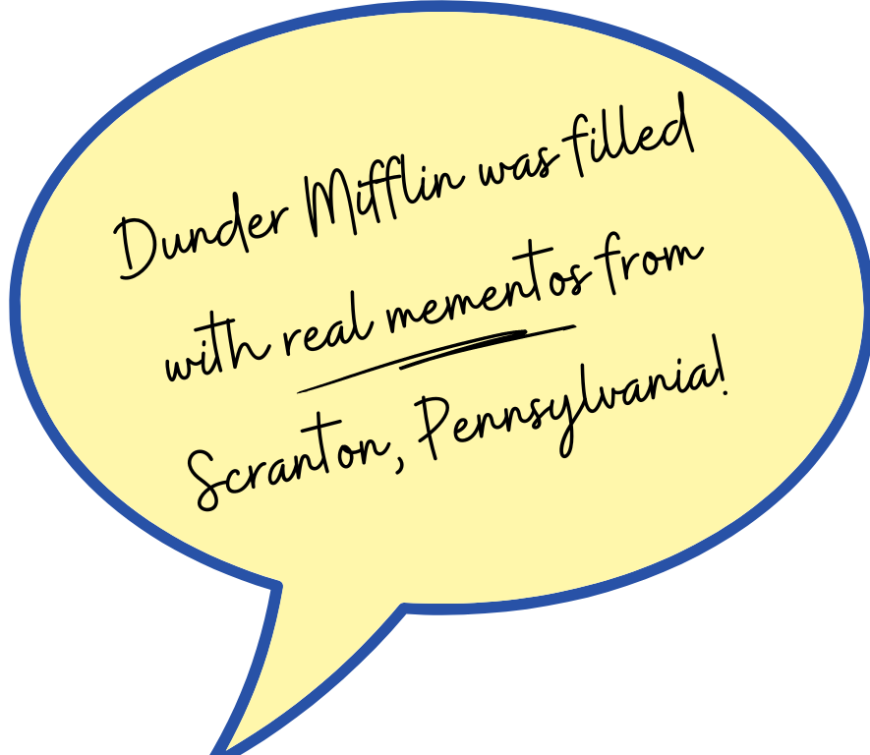 *The Office* characters regularly read authentic Scranton newspapers in the fictional Dunder Mifflin breakroom, including ***The Scranton Times*** and the former ***Electric City*.**
* Scranton was the host city for **two conventions** celebrating *The Office*, welcoming the show’s famous actors and thousands of fans to **The University of Scranton** in 2007, and **Courthouse Square** in Downtown Scranton in 2013.
* In 2021, **Peacock** officials presented the **City of Scranton** with an oversized **Dundie Award** honoring the Electric City as the “Best Hometown of T*he Office*.”

*Yeppers!*

the end

## (until our next project!)

[scrantontomorrow.org](https://www.scrantontomorrow.org/)

